# *ASSIGNMENT TEAM MEMBERS:-*

1. SAFAL ACHARYA (NPI000170)
2. RIDEN PAUDEL (NPI000168)
3. RANGIN BASNET (NPI000167)
4. SAJAG SHRESTHA (NPI000172)

# Database Schema

# Finalized ERD

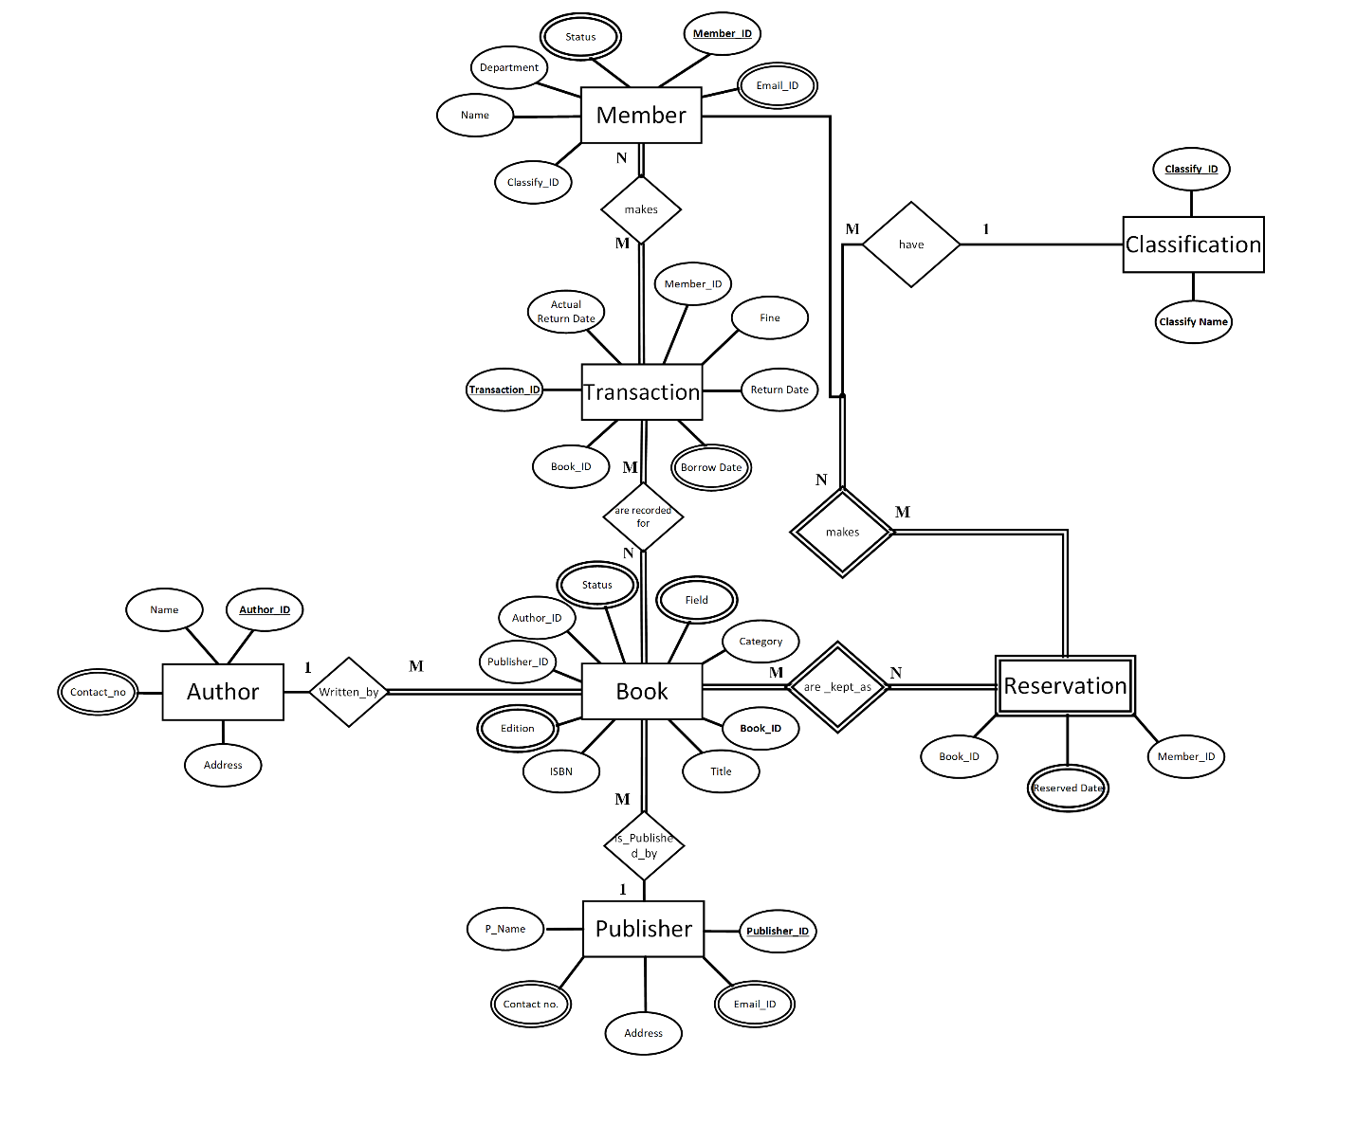

Fig: Finalized ERD

# Database Diagram

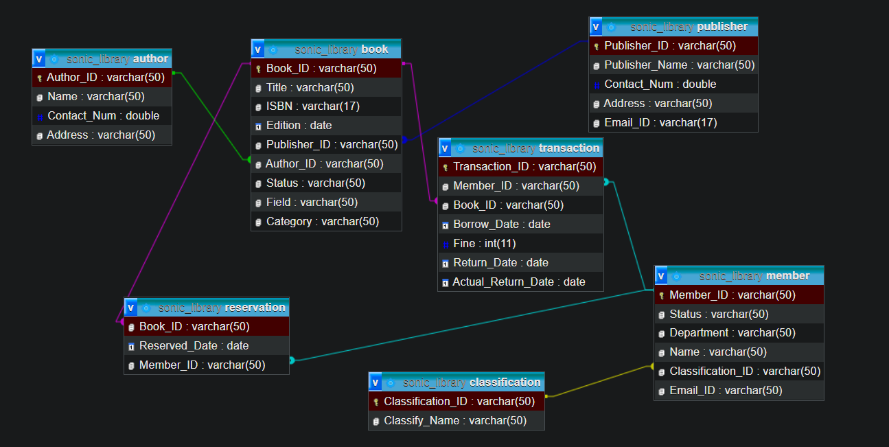

Fig: database diagram